Fuel Up District Lunch Program

We are very excited to re-launch our Fuel Up District Lunch Program! School district staff have been working closely with our meal providers to ensure feedback from last year has been heard. The caterers have made changes to how meals are distributed, to ensure all health and safety protocols are adhered to. They are exploring eco-friendly packaging, and are providing meals that are both appealing to children and healthy.

Caregivers can begin ordering lunches September 18, and the program will begin September 21.

If you received a subsidy last year, this will carry over, so families do not need to re-apply. If you would like to apply for a partial or full subsidy, please speak with your school principal.

If you have any questions, please contact fuelup@sd40.bc.ca.

Fuel Up District Lunch Program
Online Ordering Direction (see next page)
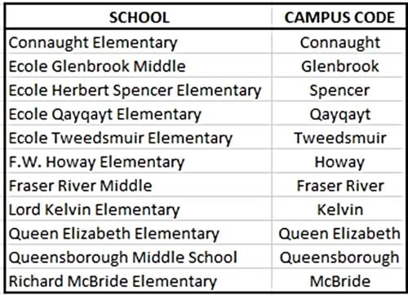
Go to:
https://readymaid.ahotlunch.ca/home
- Set up a new account.
- Add a listing for each child you’d like to order for (make sure to update classroom information at the start of each year).
- You must enter your child’s division for this year.
- “Campus Code” is the school name (listed to the right).
- Use the Orders feature to select your options!
To cancel or change your child’s lunch order:
Orders and changes must be made by noon, two days in advance of deliver (e.g. for Monday’s order, changes or cancellations must be made by noon on Saturday).
- Sign onto your account at readymaid.ahotlunch.ca.

- Select “Orders” form the menu on the left of the page.
- Select “My orders”.
- Click on ‘cancel’ beside those items you’d like to cancel.
- Select “continue ordering” on the top of the invoice.
*If your child is ill, cancellation may be made via e-mail to fuelup@sd40.bc.ca by 8:00 am on the day of illness.

