November 2, 2020
Dear Parents/Guardians:
At New West Schools, we have been working hard to provide families with regular updates on student progress. We do this in many ways; meetings, phone calls, emails, assessed work sent home for your review and parent/teacher/student conferences. We also provide three written formal report cards in November, March and June. The Ministry of Education has been working on aligning the way we report to families to support our redesigned curriculum. For more information please see:
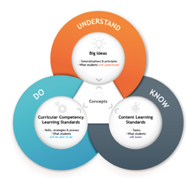
Ministry of Education Student Progress Report Order
Ministry of Education Draft Reporting Policy K-9

For the last several years we have been focusing on writing report card comments that provide clear information on what your child knows, understands and can do in each curriculum area.

This year we are making a few more changes to support our redesigned curriculum and the Draft Reporting Policy from the Ministry of Education:

- We are shifting the way we grade our students to align with a new “proficiency scale” created by the Ministry of Education. This scale uses growth mindset language and supports a continuum of learning.
- Students in K-5 will see this scale on their report card to indicate their progress
- Students in Grades 6-8 will continue to receive letter grades, with our plan to switch to proficiency scales in the 2021-2022 school year

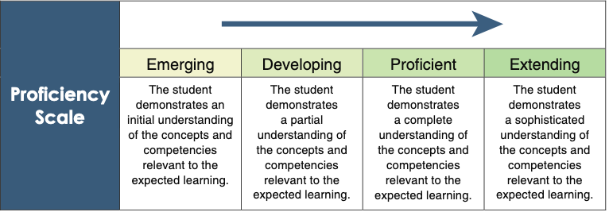

- Students will be focusing more on the essential skills of learning--the Core Competencies: Communication, Thinking and Personal and Social interaction. Students have been assessing their abilities with these competences for the past 5 years in the June reporting period. We will now be adding an additional self-reflection in the March reporting period.

- We will also be working toward “Three-Way Conferences” at least once per year. At this conference, parents/guardians, the teacher and the student will meet together to discuss progress and set goals for further learning. Many of our schools have already been working on this method of conferencing for the last few years. This approach puts students at the centre of their learning.

For more information, please view our short “Reporting Updates” video here: https://youtu.be/djax6pP3w7k
If you have any questions or concerns, please do not hesitate to reach out to your classroom teacher, Vice-Principal, or Principal.
Sincerely,

Maureen McRae-Stanger
Director of Instruction, Learning and Innovation

